DSA0410 – Fundamentals of Data Science

Day - 3

Name : Mithlesh N
Reg.no.: 192424364

11. Scenario : You are a data scientist working for a company that sells products online. You have been tasked with creating a simple plot to show the sales of a product over time.
Question:
1. Write code to create a simple line plot in Python using Matplotlib to predict sales happened in a month?
2. Write code to create a scatter plot in Python using Matplotlib to predict sales happened in a month?
3. Develop a Python program to create a bar plot of the monthly sales data.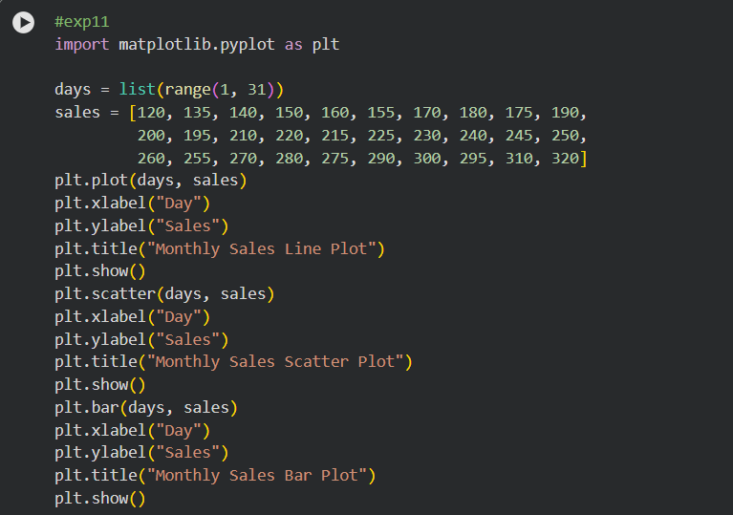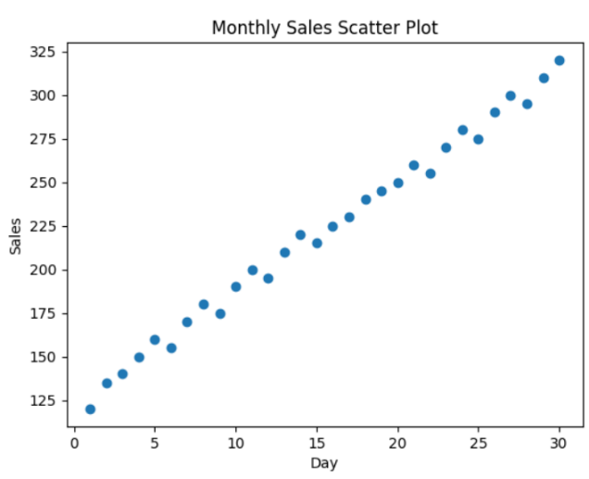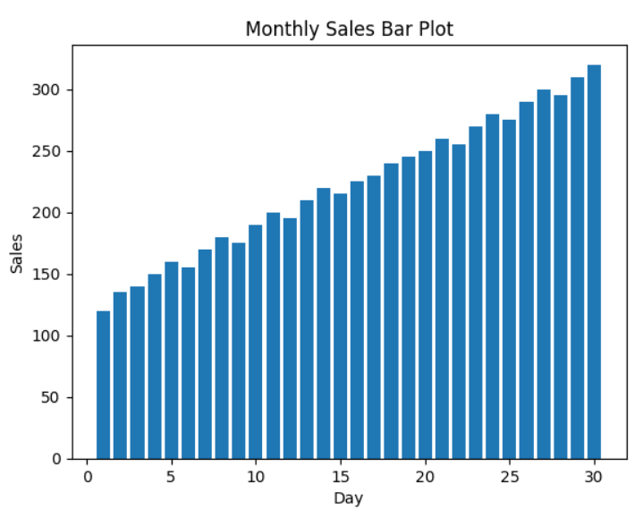

12. Scenario: You are working on a data analysis project that involves analyzing the monthly temperature and rainfall data for a city. You have a dataset containing the monthly temperature and rainfall values for each month of a year. Your task is to develop a Python program that generates line plots and scatter plots to visualize the temperature and rainfall data.
Question:
1. Develop a Python program to create a line plot of the monthly temperature data.
2: Develop a Python program to create a scatter plot of the monthly rainfall data.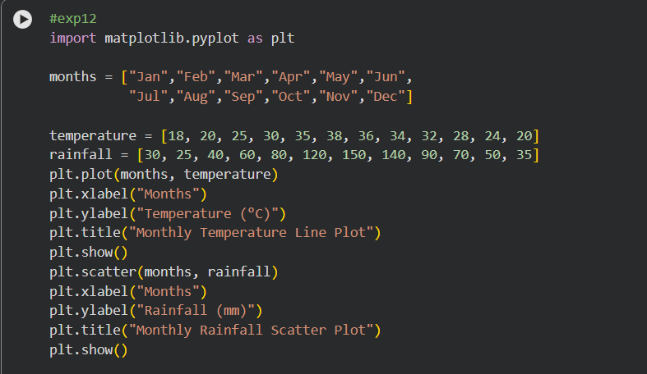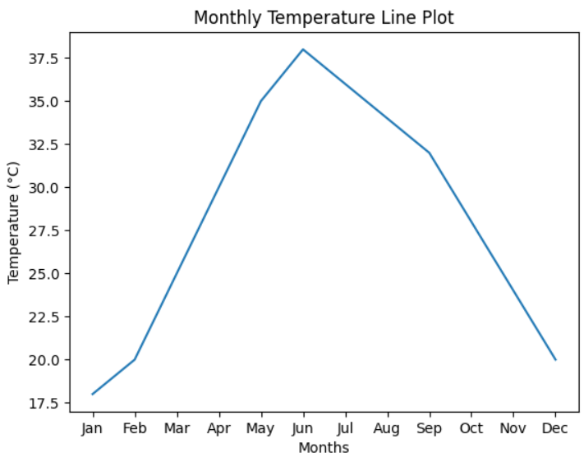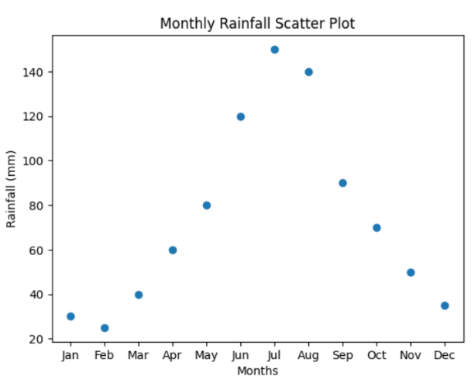

13. Scenario: You are working on a text analysis project and need to determine the frequency distribution of words in a given text document. You have a text document named "sample_text.txt" containing a paragraph of text. Your task is to develop a Python program that reads the text document, processes the text, and generates a frequency distribution of the words.
Question: How would you develop a Python program to calculate the frequency distribution of words in a text document?
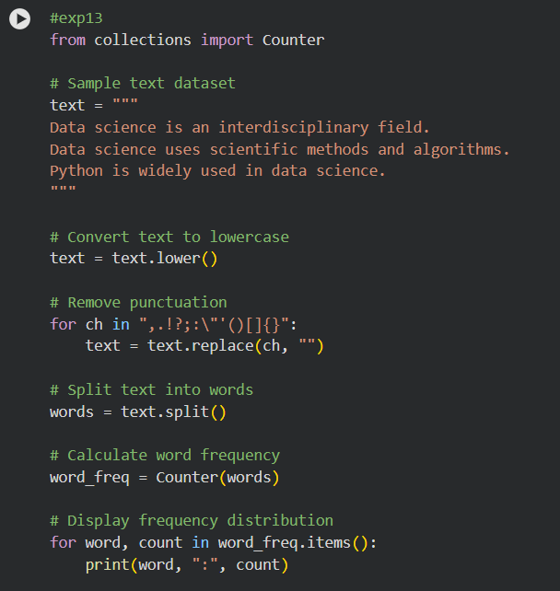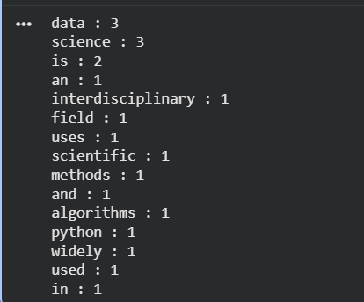

14. Scenario: You are a data analyst working for a company that sells products online. You have been tasked with analyzing the sales data for the past month. The data is stored in a Pandas data frame.
Question: Develop a code in python to find the frequency distribution of the ages of the customers who have made a purchase in the past month.
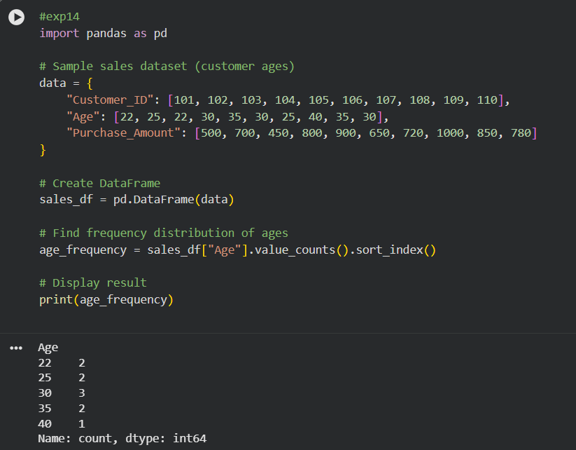

15. Scenario: You are a data analyst working for a social media platform. As part of your analysis, you have a dataset containing user interaction data, including the number of likes received by each post. Your task is to develop a Python program that calculates the frequency distribution of likes among the posts.
Question: Develop a Python program to calculate the frequency distribution of likes among the posts?

